# Do Humans Maintain a Representation of the Air Drag in their Environment?

Borja Aguado¹, Björn Jörges², Joan López-Moliner¹*

¹ Vision and Control of Action (VISCA) group, Department of Cognition, Development and Psychology of Education, Institut de Neurociències, Universitat de Barcelona, Ps. Vall d'Hebron 171, 08035 Barcelona, Catalonia, Spain.

² Center for Vision Research, York University, 4700 Keele Street, Toronto, ON M3J 1P3, Canada

*Corresponding Author

## Abstract

Humans represent and use an array of physical properties of their environment, from gravity, over the mass and size of known objects to regularities of lighting conditions. To time interceptive responses for flying targets accurately, it would be beneficial for humans to also maintain a representation of air drag. In this study, we test two hypotheses: do humans use air drag to extrapolate motion? And do humans represent the air drag-related characteristics of known objects separately? To test these hypotheses, we presented participants with parabolic trajectories in the fronto-parallel plane. The ball disappeared and subjects were asked to indicate by button press when the ball returned to its original height which was marked by an elongated table. Furthermore, they were asked to indicate where the ball hit the table. We manipulated presence or absence of air drag during the visible part of the trajectory, ball size (tennis ball size or basketball size), their texture (tennis ball or basketball texture) and initial horizontal and vertical velocities. Regarding our first hypothesis, we found some evidence that humans rely on a representation of air drag. Furthermore, we found strong evidence that expectations about air drag-related motion behavior is influenced both by the size and the texture of the target. Finally, in an exploratory analysis, we confirmed that a previously proposed relationship between perceptual biases and discrimination thresholds might also hold true for more ecological timing and spatial judgment tasks.

## Introduction

The importance of ecologically valid stimuli for the study of interceptive actions is self-evident. Nonetheless, many studies neglect air drag when simulating stimuli in virtual reality. While this can facilitate some aspects of setup and analysis, it may lead to systematic errors in results. There is evidence that humans represent and use different physical properties of their environment, such as the size of known objects (Hosking & Crassini, 2010; López-Moliner, Field, & Wann, 2007), their mass (Neupärtl, Tatai, & Rothkopf, 2020), density (Peters, Ma, & Shams, 2016), gravity (Bosco et al., 2015; Gómez & López-Moliner, 2013; Indovina et al., 2005; Jörges & López-Moliner, 2019; Jörges & López-Moliner, 2017, 2020; La Scaleia, Zago, Moscatelli, Lacquaniti, & Viviani, 2014; Lacquaniti et al., 2013; McIntyre, Zago, & Berthoz, 2001; McIntyre, Zago, Berthoz, & Lacquaniti, 2003; Mijatovic, La Scaleia, Mercuri, Lacquaniti, & Zago, 2014; Senot, Zago, Lacquaniti, & McIntyre, 2005; Senot et al., 2012; Zago, La Scaleia, Miller, & Lacquaniti, 2011) or the direction of light (Adams, Graf, & Ernst, 2004) in their interactions with the environment. It is thus not unlikely that air drag is among these properties being used in complex environments.

Air drag is an umbrella term for different effects that act opposite to the motion direction of a moving object. Different types of air drag are parasitic drag, lift-induced drag and wave drag. Parasitic drag is the force that acts upon bodies that moves through liquids (including the air). Lift-induced drag occurs when a body redirects airflow, as for example wings do. Wave drag is present when objects move around the speed of sound, as well as at the borders between different liquids. For everyday interception tasks, parasitic drag is most relevant. It is computed as follows:

|  |  |
| --- | --- |
|  | [1] |

is the drag coefficient of the respectively object; it is calculated based on the density of the surrounding fluid (1.225 kg/m³ at a temperature of 15° C in the case of air), the drag coefficient , which depends on the object shape, and the radius *r*. The drag force relates thus quadratically to velocity and diameter of the target: faster objects with a bigger cross-section are affect much more strongly by air drag than smaller, more slowly moving objects. For completeness sake, the so-called Magnus force should not be left unmentioned, which is responsible, for example, for topspin effects in ball sports like tennis. Magnus forces act upon objects that spin while moving through liquids and can drive a tennis ball downwards in an unexpected fashion. However, the current study neglects Magnus forces and focusses entirely on air drag.

Air drag can thus be envisioned as negative, dynamically developing acceleration acting opposite to the direction of motion of the target. As such, it is in two ways different from the other very common acceleration in our environment, gravity: First, the direction of the gravitational acceleration is always acting in the same direction, independently of object motion. Second, its force does not depend on the velocity of the target.

While ecological theories of perception posit that most tasks can be solved without extensive internal representation of the environment (see, e. g. Wilson & Golonka, 2013),­ computational models often rely on identifying to what extent we represent and make use of our knowledge about the world (Gómez & López-Moliner, 2013). The present study thus aims to investigate whether air drag is, like gravity, mass or density, among the physical properties of the environment represented by the brain. If this is the case, we expect systematic errors when no air drag is simulated, and an accurate performance when air drag is simulated (Hypothesis 1). If humans represent air drag, it stands to reason that they adapt their expectations to the object at hand, with regards to, for example, its size. We would thus expect predictions to be equally accurate for two objects with different sizes (Hypothesis 2). It furthermore stands to reason that humans integrate all available information to make interceptive actions as accurate as possible. For known objects, such as tennis balls or basketballs, the texture could represent such additional cues to be integrated with online visual information.We thus expect to observe systematic errors when the air drag acting upon a simulated object does not correspond to its appearance (e. g. a basketball-sized target with the texture of a tennis ball; Hypothesis 3).

## Methods

## Participants

We tested n = 20 participants (6 self-identified men and 14 self-identified women). They were between 19 and 44 years old and had all normal or corrected-to-normal vision. All of them were either colleagues from the department or Psychology students at University of Barcelona and could participate in research activities to acquire course credits. Informed consent was obtained. Data collection was conducted according to the guidelines of the Declaration of Helsinki, and the experiment was part of an ongoing project that was approved by the local ethics board.

Apparatus

We presented overlaid images on a back-projection screen (244 cm tall and 184 cm wide) with two Sony laser projectors (VPL-FHZ57). They provided a resolution of 1920 × 1080 pixels and a refresh rate of 85 Hz for each eye. Circular polarizing filters were used to provide stereoscopic images. Participants stood at 2 m distance centrally in front of the screen and used polarized glasses to achieve stereoscopic vision. The shown disparity was adapted to each participant’s interocular distance. Responses were given with a joystick.

Setup

­We presented participants with parabolic motion in the fronto-parallel plane in a rich 3D environment that provided cues about the distance to the target, at a simulated distance of 6m from the participant. The ball disappeared after reaching peak (between 55 % and 60 % of the full flight duration; the exact values was drawn randomly from a uniform distribution) and participants indicated by button press when the ball dropped back to the height it was launched from (indicated by a simulated table). Then, the ball reappeared in a random position drawn from a uniform distribution simulated point-of-impact on the table and participants used a joystick to move the ball, indicating the position where they thought the ball hit the table. The target had the texture of a tennis ball (texture) and the physical properties (size, mass, density, drag coefficient) of a tennis ball (Tennis ball, Congruent), the texture of a basketball and the physical properties of a basketball (Basketball, Congruent), the texture of a tennis ball and the physical properties of a basketball (Tennis ball, Incongruent) or the texture of a basketball and the physical properties of a tennis ball (Basketball, Incongruent). For the tennis ball, we simulated a radius of 0.033 m and a mass of 0.06 kg. For the basketball, we assumed 0.12 m radius and a mass of 0.12 kg. Since the drag coefficient for both tennis balls (, Chadwick & Haake, 2000) and basketballs (, see Okubo & Hubbard, 2010) are very similar due to their nearly identical shape, we chose an intermediate value of 0.535 for both. We simulated no spin and neglected Magnus forces. The ball could start with an initial horizontal velocity of 3.0 or 3.5 m/s. The initial vertical velocity was given such that the overall flight time (visible + invisible) was 1.0, 1.2 or 1.4 s for the Tennis Ball, Congruent, without air drag conditions and ranged between 4.9035 and 6.8649 m/s. We matched the initial vertical velocities for the other conditions, which lead to slight differences in overall flight duration (0.98 to 1.0 s; 1.17 to 1.2 s; 1.352 to 1.4 s) and horizontal length of the trajectory.

In half of trials, the trajectory unfolded in the absence of air drag, that is the target’s x and y positions were given by the regular equations for parabolic motion:

|  |  |
| --- | --- |
|  | [2] |
|  | [3] |

is the *x* position in time; is the horizontal acceleration, which for motion with air drag is constant at 0 m/s²; *t* is the time that has passed since inception of the trial; refers to the horizontal velocity, which is constant without air drag; is the *y* position in time; is the vertical acceleration, which for motion without air drag is constant at earth gravity (-9.81 m/s²); and refers to the initial vertical velocity.

The other half of trials were simulated under the influence of air drag, where we compute acceleration and velocities dynamically on each frame according to the following equations:

|  |  |
| --- | --- |
|  | [4] |
|  | [5] |
|  | [6] |
|  | [7] |
|  | [8] |
|  | [9] |
|  | [10] |

, , , , and are *x* position, *y* position, horizontal velocity, vertical velocity, tangential velocity, horizontal acceleration and vertical acceleration in time, respectively; g is earth gravity (9.807 m/s²), is the drag force (see Equation 1) and *m* is the mass of the object (0.06 kg for the tennis ball and 0.6 kg for the basketball).

## 

Figure : A. Trajectories per initial horizontal velocity, time-to-contact and ball type in the context of a 2D image of the visual scene. The gold parts close to the peak illustrate the range during which the ball disappeared. B. Simulated horizontal acceleration over time. The flat line intercepting the y axis at y = 0 indicates acceleration under the “Air Drag: Absent” condition. C. Same as B, but for the vertical acceleration; again, the flat line interception the y axis at y = 9.807 indicates acceleration in the “Air Drag: Absent” condition. D. Simulated effective times-to-contact per time-to-contact. Different icon types denote whether the physical properties of the object corresponded to a Basket (circle) or Tennis (triangle) ball. Colors illustrate whether air drag was present (blue) or not (red). E. Same as D, but for the point of impact.

While longer flight durations would have lead to greater differences between “Airdrag: Present” and “Airdrag: Absent”, it was important to provide as realistic an environment as possible, as it has been shown previously that humans only apply some of their knowledge about the world when the display is immersive enough (Zago et al., 2011). Temporally and spatially longer trajectories would have required us to simulate the targets at even greater distances, making virtual reality-related biases in distance perception (Messing & Durgin, 2005) more likely. For the sake of more ecologically valid circumstances, we thus opted for an intermediate distance and shorter presentation times. Figure 1 provides an oversight over different parameters of our stimuli.

Before commencing the main part of the experiment, each subject was asked to move around in the virtual environment using a joystick. This was done so that the participants could become familiar not only with the environment, but also with the actual size of the balls presented in this experiment. After giving them about half a minute to familiarize themselves with the experiment, they underwent 48 training trials (each condition combination once) in which the ball reappeared when they pressed the button used to time their response. This gave them spatial cues about their error and allowed them to attune to the task and the visual scene.

The Python program used to present the stimuli and collect the data has been uploaded on Open Science Foundation (<https://osf.io/8gxp7/>).

## Data Analysis Plan and Predictions

We first standardized responses times and spatial errors by adding them to the extrapolated duration or space and then dividing them by the extrapolated duration or space. This way, we achieve a standardized value that is comparable across the different times-to-contact, where 1 indicates perfect accuracy, values below one denote too early temporal responses or an undershoot and values above one denote too late temporal responses or an overshoot.

|  |  |
| --- | --- |
|  | [11] |
|  | [12] |

We then removed those trials as outliers where the Error Ratio was smaller than 0.25 or greater than 4. Here, we excluded 1180 of an initial 19200 trials, that is 6.18 % of all trials. In a second step, we removed those trials where either of the error ratios lay more than 1.5 times the interquartile distance above the upper quartile or below the lower quartile. This algorithm lead to a loss of another 977 trials, or 5.4 % of the remaining trials. We then proceeded to test our hypotheses with a combination of Linear Mixed Modelling (Bates, Mächler, Bolker, & Walker, 2015) and Bayesian Linear Mixed Modelling (Bürkner, 2018; Stan Development Team, 2016). Linear Mixed Modelling allows to estimate intercepts and regression coefficients across the whole population (“fixed effects”) or separately for sub-groups of the population (“random effects”). This allows us to separate between variability in responses due to the effect in question, and variability due to other sources, e. g. idiosyncrasies of each participant. Bayesian Linear Mixed Modelling extends this framework by estimating whole distributions for each fixed and random effect, thus allowing us to test for variability differences. It furthermore enables the application of priors; we, however, will will not make use of this feature in the present paper, and rely on the very shallow default prior implemented in the brms package.

We test each hypothesis both temporally and spatially. For **Hypothesis 1**, we expect humans to use their internalized knowledge of air drag in their habitual environment to predict object motion. Therefore, performance should be accurate for those trials where air drag is simulated and systematic errors should be observed when the trajectory unfolds without the influence of air drag. In the temporal task, participants are expected to respond too late when no air drag is simulated in the visible part of the trajectory because air drag would slow the target down on its way from peak back to the initial level. (*Prediction 1a*). In the spatial task, participants should expect the ball to be slowed down by air drag, so we predict an undershoot in participant responses (i. e. they place the object too far to the left; *Prediction 1b*). We first test whether there are any differences between both conditions via Linear Mixed Modelling, and then quantify via Bayesian Linear Mixed Modelling in which of the two conditions participants are more accurate.

For Hypothesis 2, we expect that temporal and spatial errors are comparable for targets of tennis ball size and targets of basketball size. To quantify how similar errors are between these two conditions, we use Bayesian Linear Mixed Models.

For **Hypothesis 3**, we expect the texture of the object to affect how participants extrapolate motion. For the target with tennis ball texture, but basketball size and mass (Tennis, Incongruent), participants should respond slightly later than for the target with basketball texture and basketball size. For the target with basketball texture, but tennis ball size and mass, participant should respond slightly earlier than for the target with tennis ball texture and tennis ball size (*Prediction 2a*). In the spatial domain, we expect participants to undershoot (i. e. they perceive the point of impact too far to the left) for the Basketball, Incongruent target with regards to the “Tennis Ball, Congruent”, and an overshoot (i. e. they perceive the point of impact too far to the right) for the “Tennis Ball, Incongruent” target with regards to the “Basketball, Congruent target” (*Prediction 2b*).

All data, as well as the R script used to analyze the data, can be found on GitHub (<https://github.com/b-jorges/AirDrag>).

## Results - Confirmatory Analyses

We will first conduct confirmatory analyses to test our main **Hypotheses 1 and 2** via our *Predictions 1a, 1b, 2a and 2b*.

### Hypothesis 1: Representation of Air Drag

First, we test the timing responses (*Prediction 1a*). We expect high accuracy for “Air Drag: Present” and too late responses for “Air Drag: Absent”. Figure 2A displays the distribution of responses for the timing task. To test our hypothesis, we use Linear Mixed Modelling, implemented in the package lme4 (Bates et al., 2015; Bürkner, 2018) for R. We fit a Mixed Model with air drag as fixed effect (a binary categorical variable with the values “Present” and “Absent”) and random intercepts per participant to explain timing error ratio. In lme4 syntax, the Mixed Model is specified as:

|  |  |
| --- | --- |
|  | [13] |

We compared this Test Model to a Null Model that doesn’t contain the variable of interest:

|  |  |
| --- | --- |
|  | [14] |

A Likelihood Ratio Test showed that the Test Model is significantly better than the Null Model (p = 0.003). The regression coefficient for the fixed effect “Air Drag: Absent” is 0.016 (SE = 0.005), indicating that responses occurred later in this condition. Humans thus use the same internalized knowledge to extrapolate motion independently of whether air drag was presented during the visible part of the trajectory or not. This result alone is, however, agnostic to whether humans consistently use air drag or consistently don’t use air drag for motion extrapolation, as in both cases, responses would occur later in the “Air Drag: Absent” condition than in the “Air Drag: Present” condition. The tiebreaker to this question is which of the conditions is more accurate (i. e. an error ratio closer to 1). In our frequentist framework, we can ascertain if the intercept of the Mixed Model differs significantly from one in either of the conditions. To this end, we establish a Mixed Model for each condition separately where we coerce the Intercept to be one:

|  |  |
| --- | --- |
|  | [15] |

We compare this Test Model to a Null Model where we allow the Intercept to vary:

|  |  |
| --- | --- |
|  | [16] |

For neither for the two conditions (“Airdrag: Present” and “Airdrag: Absent”), the Test Model is significantly better than the Null Model (p = 0.679 and p = 0.797, respectively).

A frequentist approach does, to our knowledge, not allow to quantify in which of the two conditions performance is more similar to perfect accuracy. To this end, we use Bayesian Linear Mixed Modelling, implemented in the packages brms (Bürkner, 2018) and rstan (Stan Development Team, 2016) for R (R Core Team, 2017). Brms allows the use of a flat prior, in which case the posterior corresponds to the likelihood. We choose this options because our objective is not to use prior information, but rather to quantify support for a null hypothesis. Brms uses the same syntax as lme4; we thus fit the following model:

|  |  |
| --- | --- |
|  | [17] |

Brms does not require testing of a Test Model against a Null Model. Rather, we can use the hypothesis() function to test to what extent the data supports certain hypotheses. In our case, the hypothesis is whether performance for “Air Drag: Present” (i. e. the intercept) differs more from 1 than performance for “Air Drag: Absent” (i. e. the intercept plus the regression coefficient for “Air Drag: Absent”). This test returns a posterior probability of 0.38, which corresponds to an Evidence Ratio of 0.61 (“Air Drag: Present” is 0.0037 further away from 1, SE = 0.016, 95 % CI = [-0.02; 0.021]); that is the data support accuracy to be higher for the Air Drag: Absent condition, albeit to a very limited extent.

For the spatial task (*Prediction 1b*), we expect high accuracy for “Air Drag: Present” and an undershoot for “Air Drag: Absent”. Figure 2B visualizes the distribution of responses for each condition. We follow the same procedure as for the timing response and fit the following Test Model:

|  |  |
| --- | --- |
|  | [18] |

We then compare it to the following Null Model:

|  |  |
| --- | --- |
|  | [19] |

By means of a Likelihood Ratio Test, we found that the Test Model is significantly better than the Null Model (p < 2.2*10^16). The regression coefficient for “Air Drag: Absent” is -0.022 (SE = 0.002). We again test whether the intercepts differ significant from 1 in either condition. We find that the intercept does not differ for the “Air Drag: Present” condition (p = 0.056), while it does differ significantly for the “Air Drag: Absent” condition (p = 0.016). However, considering that the intercept for “Air Drag: Present” is only marginally not-different from 1, we again perform the Bayesian analysis outlined above with the following model:

|  |  |
| --- | --- |
|  | [20] |

Here, we find a Posterior Probability of 0.97, corresponding to an Evidence Ratio of 33.78, in favor of “Air Drag: Present” eliciting more accurate responses (“Air Drag: Present” is 0.02 closer to 1, SE = 0.007, 95 % CI = [0.016; 0.025]). This represents moderate-to-strong evidence that humans use internalized knowledge of Air Drag to extrapolate motion.

Overall, our data represents strong evidence that humans do not switch between an air drag-based model and a non-air drag-based model for motion extrapolation, but rather use the same model independently of what is presented to them. The timing task furthermore provides weak evidence in favor of an air drag-independent model, while the spatial task provides relatively strong evidence in favor of an air drag-based model.

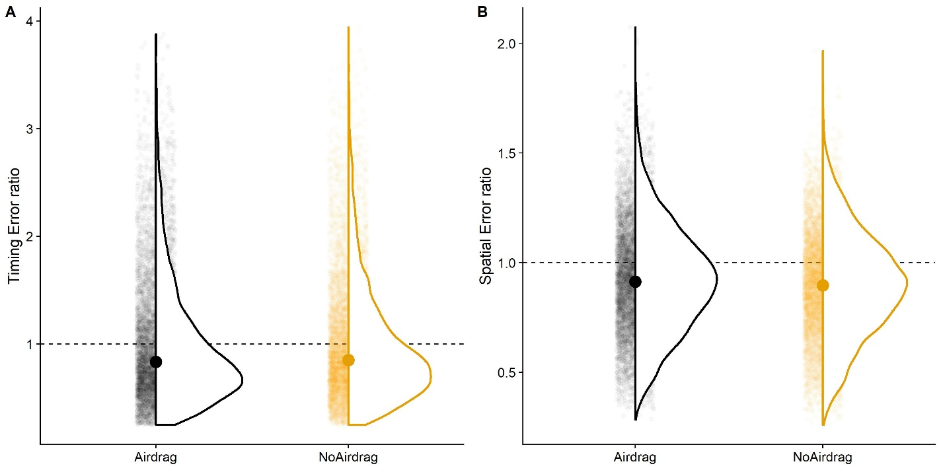

Figure : Distribution of responses error ratios for Airdrag and No Airdrag. Each small transparent dot represents one trial. The dotted line indicates a timing error ratio of 1, that is perfect accuracy. A. Timing task. B. Spatial task.

### Hypothesis 2: Target size and air drag-related extrapolation

We furthermore hypothesized that humans might extrapolate motion taking into account that air drag affects objects of different physical sizes differently. To test this hypothesis, we use non-Bayesian Linear Mixed Modelling to fit the following models for those trajectories w

|  |  |
| --- | --- |
|  | [29] |
|  | [30] |

And compare them again Null Models without Ball Size as fixed effect:

|  |  |
| --- | --- |
|  | [31] |
|  | [32] |

We tested the Test Models against the Null Models with a Likelihood Ratio Test and found the variable “Ball Size” did not improve the model fit significantly for the temporal task (p = 0.422). This alone, however, does not provide strong evidence that humans adapt their predictions to the size of the object at hand, as differences in the temporal domain are quite small between “Air Drag: Absent” and “Air Drag: Present” (see Figure 1D). For the spatial task, however, differences are much more pronounced (see Figure 1E). And indeed, Ball Size improved the model fit significantly (p < 2.2*10^16). The regression coefficient for “Ball Size: 0.12 m” was 0.024 (SE = 0.002); the larger targets thus lead observers to perceive a larger overshoot than smaller objects. This perceived difference corresponds roughly to the physical differences between trajectories; that is, the observers seem to use the same air drag model independently of the size of the object, against our prediction.

### Hypothesis 3: The influence of context information on motion extrapolation

Furthermore, we expect humans to perform accurately regardless of the target type when air drag is present when the physical properties correspond to the visible properties of the target. For the “Tennis Ball, Incongruent condition”, we expect responses to be slightly later than for the “Tennis Ball, Congruent condition”. For the Basketball, Incongruent condition, we expect responses to be slightly earlier than for “Basketball, Congruent” (*Prediction 3a*). We employ Linear Mixed Modelling implemented in the package lme4 (Bates et al., 2015; Bürkner, 2018) for R for both timing and spatial responses. For the timing responses, the model contains ball type (“Tennis”, “Basket”), congruency between visual and physical properties (“Congruent”, “Incongruent”) and their interaction as fixed effects and random intercepts per participant as random effects. In brms syntax, the model is specified as follows.

|  |  |
| --- | --- |
|  | [21] |

To ascertain whether the data support our predictions, we compared this Test Model to a Null Model that doesn’t contain the interaction term. In lme4 syntax, it is specified as follows:

|  |  |
| --- | --- |
|  | [22] |

A Likelihood Ratio Test (anova() function in R) showed that the Test Model is not significantly better than the Test Model (p = 0.778); our Hypothesis 2a is thus not supported by the data. However, it was quite unlikely to observe an effect in this condition as the expected differences in the temporal domain between the congruent and incongruent conditions were extremely small (between 2 and 8 ms).

We performed the same procedure for the spatial task (*Prediction 3b*). Here we compared the Test Model

|  |  |
| --- | --- |
|  | [23] |

to the Null Model

|  |  |
| --- | --- |
|  | [24] |

again with a Likelihood Ratio Test (anova() function in R). The Test Model proved to be significantly better than the test model (p < 2.2*10^16). It estimates the regression coefficient for the interaction of “Ball Type: Basketball” and “Congruency: Incongruent” -0.063 (SE = 0.007), which is the predicted direction. We visualize the response distribution for each combination of ball type and congruency level in Figure 3. Our Hypothesis 2b, namely that humans use visual cues (such as texture) about their targets to predict their air drag-related behavior in the spatial domain, is thus supported by the data.

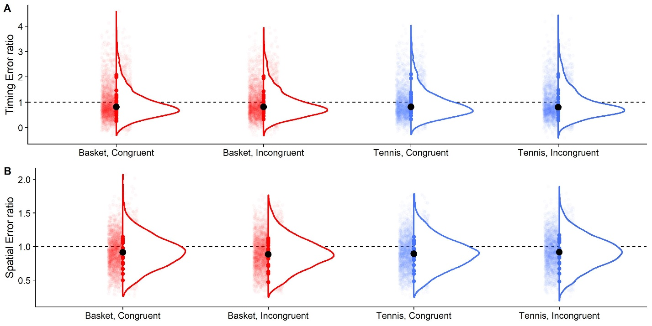

Figure : Distribution of errors per ball type and congruency condition. Each transparent dot represents one trial. The dotted line represents an error ratio of 1, that is perfect accuracy. Small translucid points represent individual trial data. Medium colored points at the bottom of the curve indicate median per participant. Big black dot indicates median across participants. A. Timing errors. B. Spatial errors.

## Exploratory Analyses

We furthermore explore several potential candidate hypotheses for future confirmation.

### Is precision lower when no air drag is presented in the visible part of the trajectory?

Humans might pick up subtle differences in trajectories unfolding with or without air drag, which might interfere with their model of target motion and lead to more variable responses. To test this hypothesis, we use the Bayesian Mixed Models fitted above (Equation 17 for the temporal responses and Equation 20 for the spatial responses) and test the hypothesis that “Air Drag: Absent” leads to a loss in precision. For the timing task, we find a Posterior Probability of 0.66 and an Evidence Ratio of 1.96, with the standard deviation for “Air Drag: Absent” 0.001 milliseconds higher than for “Air Drag: Present” (SE = 0.003, 95 % CI = [-0.004; 0.006]), in favor of this hypothesis. That is, the data supports slightly more our hypothesis than the counter hypothesis that “Air Drag: Absent” increases precision. For the spatial task, we find the estimated standard deviation to be 0.002 higher for “Air Drag: Present” than for “Air Drag: Absent” (SE = 0.002, 95 % CI = [-0.0004; 0.004]). This corresponds to Posterior Probability of 0.07 and an Evidence Ratio of 0.06, that is, the data provide more support for the hypothesis that “Air Drag: Absent” *increases* precision. Overall, our data do not provide strong support for any relationship between air drag and response variability.

### Does variability in responses differ between congruent and incongruent trials?

It stands to reason that a conflict between texture and other physical (air drag-relevant) properties could lead subjects to extrapolate motion less precisely. As testing for variability differences is not straight-forward with traditional Linear Mixed Models, we again employ Bayesian Linear Mixed Modelling. We establish a Test Model with Congruency (“Congruent”, “Incongruent”) as fixed effect and random intercepts per participant as random effects:

|  |  |
| --- | --- |
|  | [25] |

We found the standard deviation for “Congruency: Congruent” to be 0.006 higher than for Congruency: Incongruent (SE = 004, 95 % CI = [-0.005; 0.13]). This corresponds to a Posterior Probability of 0.06 and an Evidence Ratio of 0.07 in favor of the hypothesis that “Congruency: Congruent” elicits a higher precision. The data thus provide some support for the alternative hypothesis, namely that “Congruency: Incongruent” leads to more precise responses in the timing task.

We then repeat the same procedure for the spatial task. The specified model is:

|  |  |
| --- | --- |
|  | [26] |

Here, we also find variability to be slightly lower in the “Congruency: Incongruent” condition, by 0.004 (SE = 0.005, 95 % CI = [0.0008; 0.009]). This corresponds to a Posterior Probability of 0.03 and an Evidence Ratio of 0.03 in favor of our original working hypothesis. This represents, again, some evidence that variability might actually be *lower* for conflicting textures and sizes.

Overall, we found for both tasks that variability was decreased slightly for the incongruent condition. However, the differences are extremely small, and might have their source in other effects, such as observers attending more strongly to unexpected stimuli.

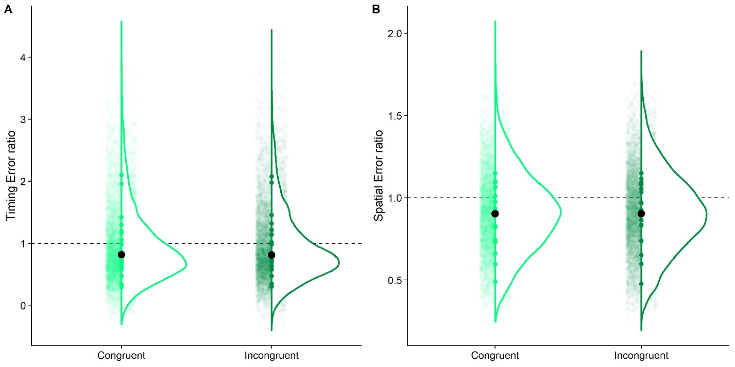

Figure : Distribution of errors for trials where the ball texture was congruent with its size and other physical properties (Congruent) and where they were incongruent (Incongruent). . Small translucid points represent individual trial data. Medium colored points at the bottom of the curve indicate median per participant. Big black dot indicates median across participants. The dotted line represents an error ratio of 1, that is perfect accuracy. A. Timing errors. B. Spatial errors.

### Do different object sizes elicit differences in conditions?

It is furthermore possible that performance is affected by the simulated objects. For example, performance for tennis ball-sized targets (“Tennis Ball, Congruent” and “Basketball, Incongruent”) could be less precise because they are smaller, which might lead to a less precise representation of their size, as estimates of the visual angle get more precise for higher values. Figure 5 gives some indication that there might be differences, especially for the spatial task. We thus employ the same procedure as in the previous section, and fit the following model, with Ball Size (0.033 m and 0.12 m) as fixed effect and random intercepts per participants as random effects:

|  |  |
| --- | --- |
|  | [27] |

We find that the standard deviation for the bigger ball size was slightly higher than for the smaller ball size (by 0.007, SE = 0.003; 95 % CI = 0.002;0.012]). This corresponded to a Posterior Probability of 0.01 and an Evidence Ratio of 0.01 for the original hypothesis that smaller balls should lead to higher variability. This represents moderate evidence that smaller balls lead to higher precision.

We conducted the same analysis for the spatial error:

|  |  |
| --- | --- |
|  | [28] |

We found that the standard deviation for the smaller ball was, again, lower than for the bigger ball (by 0.0008, SE = 0.0035, 95 % CI = [-0.002; 0.004]). This corresponded to a Posterior Probability of 0.3 and an Evidence Ratio of 0.44, thus supporting slightly more the alternative hypothesis that smaller objects lead to increased precision. Overall, this represents some evidence that smaller targets did not lead to precision losses in our task. This can be taken as evidence that the visual angle has a very subordinate role for both temporal and spatial judgements at an intermediate distance in the fronto-parallel plane.

Overall, this exploratory analysis shows that smaller targets might lead to a slightly increased precision, and that target size bears no impact on timing accuracy, while it has a small, but robust influence on accuracy for spatial extrapolation.

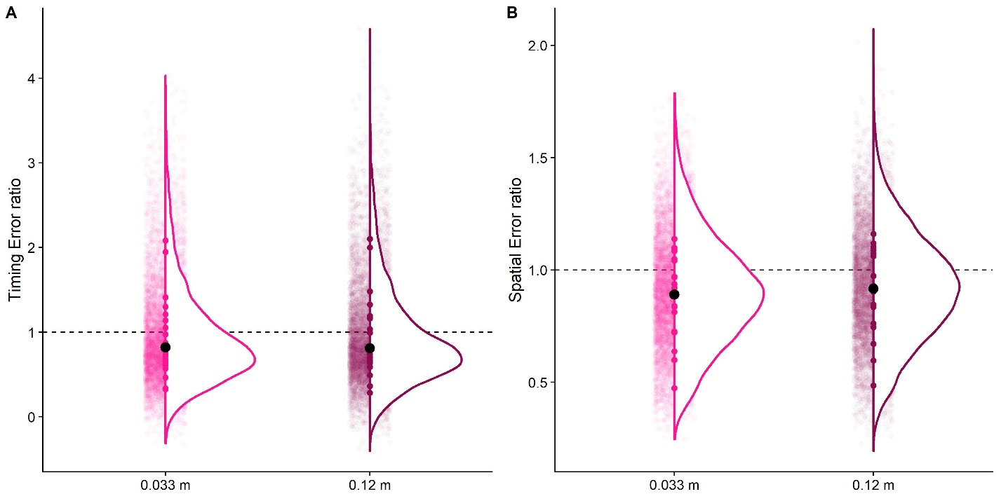

Figure : Distribution of errors for trials where the ball was of tennis ball size (0.033 m) and where the ball was of basketball size (0.12 m). The dotted line represents an error ratio of 1, that is perfect accuracy. . Small translucid points represent individual trial data. Medium colored points at the bottom of the curve indicate median per participant. Big black dot indicates median across participants. A. Timing errors. B. Spatial errors.

### Is there a lawful relation between biases and variability?

It has recently been argued that there is a lawful, linear relationship between perceptual biases and perceptual precision (Wei & Stocker, 2017). While the authors have proposed this link for lower level perceptual processes, as employed in simple discrimination tasks, it stands to reason that similar relationships could also hold for higher level processes. To test whether our dataset supports this notion, we computed normalized standard deviations (“SD Ratio Timing” and “SD Ratio Distance”) for participant responses by computing the standard deviation per condition (horizontal velocity, time-to-contact, air drag condition, ball type and congruency condition) and participant. We then normalized the standard deviations by dividing them by the mean Occluded Time or the Occluded Distance, respectively, in the condition combination over which the standard deviation was computed. To test statistically whether there is a relationship between biases and variability, we used Linear Modelling. We fitted a simple model with the normalized standard deviations as fixed effect.

|  |  |
| --- | --- |
|  | [33] |
|  | [34] |

For both the timing task and the spatial task, the respective normalized standard deviations explained a significant amount of variability in responses. For the timing errors, the regression coefficient for SD Ratio Timing was 2.02 (SE = 0.06; p < 2*10^16). For the spatial errors, the regression coefficient for SD Ratio Distance was 1.947 (SE = 0.1; p < 2*10^16). Note that these models do not distinguish between within-subject and between-subject variability. To determine whether this overall relationship was driven by within- or between-.subject effects, we first established Linear Mixed Models with the normalized standard deviations (“SD Ratio Timing” and “SD Ratio Distance”) as continuous fixed effects and variable intercepts per participants as random effects, with the goal of testing whether variability was significantly related to bias within-subjects. We specified the models as follows:

|  |  |
| --- | --- |
|  | [35] |
|  | [36] |

We then compared these Test Models to the following Null Models.

|  |  |
| --- | --- |
|  | [37] |
|  | [38] |

We found both Test Models to be significantly better than the Null Models. For the timing task, we found a regression coefficient for SD Ratio Timing of 0.088 (SE = 0.038; p = 0.021). For the spatial task, we found a regression coefficient for SD Ratio Distance of 0.57 (SE = 0.052; p < 2*10^16).

We tried to repeat this test with the same fixed effects, but condition combination as random effects, to assess whether participants who displayed higher variability also displayed a stronger bias. “Condition” refers here to a categorical variably where each level corresponds to one of combinations of two initial horizontal velocities, two ball sizes, two congruency conditions, presence or absence of airdrag and three times-to-contact), making for a total number of 48 levels. We thus specified two Linear Mixed Test Models with SD Ratio Timing and SD Ratio Distance as fixed effects and variable intercepts per Condition, respectively, and the corresponding Null Models without the fixed effects. We could, however, not proceed to a comparison between Test and Null Models because the random intercepts per Condition were not sufficiently different, which resulted in a singular fit. That is, the model basically omitted the random effect and estimated a regular Linear Model instead, thus not allowing us to assess the impact between-subject variability separately. We thus employed Bayesian Linear Mixed Modelling to test this hypothesis. We fit the following models:

|  |  |
| --- | --- |
|  | [39] |
|  | [40] |

Using the hypothesis() function, we tested whether the fixed effects had positive regression coefficients. For the timing condition, we found a regression coefficient of 2.27 s (SE = 0.06, 95 % CI = [2.167; 2.377]), a Posterior Probability of 1 and the corresponding infinite Evidence Ratio. For the spatial task, we found regression coefficient of 1.78 m (SE = 0.08, 95 % CI = [1.655; 1.924]), a Posterior Probability of 1 and the corresponding infinite Evidence Ratio.

We find thus compelling, albeit exploratory, evidence that both within-subject and between-subject variability in both the timing and the spatial task were linked to biases. Figure 6 represents a graphical depiction of the relationship between response variability and response bias.

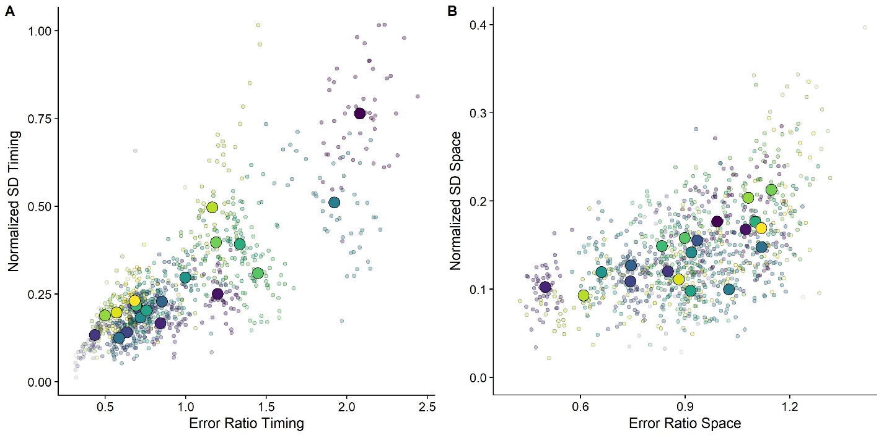

Figure 6: Error Ratios plotted against normalized standard deviations. Big dots denote the means per subject and smaller transparent dots denote the means per Condition combination. Participants are color-coded. A. Timing Task. B. Spatial Task.

# Discussion

## Do Humans Rely on a Representation of Air Drag?

This study set out to study whether air drag is among the physical properties humans represent about the world. Our study supports this hypothesis to some extent: our data support strongly the hypothesis that humans do not switch between an air drag and no air drag model according to the motion they observed. Anecdotally, our participants did not consciously notice any difference between Air Drag: Present and Air Drag: Absent trials. While differences between trajectories simulated under air drag and trajectories simulated without drag are quite small, humans have, in principle, sufficient cues available to judge at least slightly above chance whether a certain trajectory is simulated under air drag. That our participants did not switch between models, is, however, in line with what has been observed with regards to other representations of world physics. While there is ample evidence that humans rely on a gravity representation for many interception tasks (Jörges & López-Moliner, 2017; Zago, McIntyre, Senot, & Lacquaniti, 2008, 2009), we also know that they perform quite badly when they have to make conscious judgments about visually perceived gravities (Jörges, Hagenfeld, & López-Moliner, 2018). Furthermore, humans rely on gravity-based estimates for interception even when this is disadvantageous and leads to biases (McIntyre et al., 2003; Zago et al., 2004a), and even after extensive training (Zago et al., 2004b). Similarly, the observation that nor presence nor absence of air drag lead to material changes in response variability lends support to the notion that humans did not pick up discrepancies between their internal model of the motion and the observed motion.

While our data provide compelling evidence that humans use either an air drag-based model or an air drag-independent model rather than switching between both, our conclusions are less clear which of the two models humans use. While in our timing task we observe slightly more accurate responses for the “Air Drag: Absent condition”, there is moderate-to-strong evidence that behavior in the spatial task is more accurate for the “Air Drag: Present” condition. Overall, we thus provide some evidence that humans rely on an air drag-based model for motion extrapolation.

It has to be noted that, especially in virtual reality, it is hard to eliminate biases the not quite ecological presentation introduces. For example, it has been observed that distances are often underestimated in virtual reality (Messing & Durgin, 2005). However, gravity has been suggested to serve as a mediator between space and time perception (Lacquaniti et al., 2015). Since the stimuli in our experiment were governed by a gravitational motion profile, virtual reality biases should thus be reduced with respect to stimuli that behave not according to earth gravity (Jokisch & Troje, 2003; Lacquaniti et al., 2015; Vallortigara & Regolin, 2007). And in fact, we have observed a near perfect accuracy for 1g trajectories in a previous experiment with a very similar setup (Jörges & López-Moliner, 2019). Nonetheless, it is evident from the consistently too-early responses in the present experiment that we were unable to eliminate hypothesis-unrelated biases completely.

Furthermore, depth perception is not perfect in virtual reality, so a smaller optic size of the object could lead subjects to interpret that object as further away. And if participants perceive the object as further away, they might time responses too late because the same visual flow information about the distance between the point of disappearance and the target table would correspond to a larger physical distance. This is unlikely because our trajectories are governed by earth gravity, and earth gravity has been shown to help interpret visual motion in its context (Jokisch & Troje, 2003; Lacquaniti et al., 2015; Vallortigara & Regolin, 2007). However, this process might compensate only partially for misperceptions in depth.

## Do Humans form expectations about air drag-related motion based on visual and context cues?

Our second goal for this study was to verify whether responses were biased by visual cues (such as the visual size of the object; Hypothesis 2) and context information (such as the texture of the observed objects; Hypothesis 3). For Hypothesis 2, we find evidence that the size of the target may not be taken into account fully when extrapolating motion: while there was a general undershoot, observers consistently made more positive errors when judging how far the bigger objects travelled with regards to the smaller objects. They thus failed to fully account for the fact that air drag affects bigger objects more strongly than smaller objects. However, the errors they made were

For Hypothesis 3, we found compelling evidence in its support. While differences in the timing task were generally too small to detect an effect reliably, the spatial task produced a robust effect: “Tennis ball, Incongruent targets” (that is, targets of basketball size and properties, but with a tennis ball texture) were perceived to travel further than “Basketball, Congruent targets” (basketball size and basketball texture). “Basketball, Incongruent targets” (targets of tennis ball size and properties, but a basketball texture), were perceived to travel less far than their “Tennis ball, Congruent” (tennis ball size and texture) counterparts.

There are two possible explanations for this effect. Firstly, humans might adjust their internal model of air drag according to visual cues such as texture. Seeing a tennis ball texture on a basketball sized target might lead humans to adjust their interpretation of the target size slightly, and judge it to be slightly smaller than visual information alone would suggest – thus changing expectations about its behavior under air drag. Interestingly, while a mismatch between texture and size might introduce uncertainty in the system, we verified in an exploratory analysis that incongruency between texture and size did not incur precision losses. Indeed humans seem to have a tendency to adjust their estimate of a target size according to its texture when the object is known to them, even when this leads to inaccurate interceptive actions (López-Moliner & Keil, 2012). The reason is likely that input from the optic flow, more specifically the visual angle, is a very noisy source of information about object size (McKee & Welch, 1992). Therefore, size judgements are heavily affected by prior knowledge, and more so if this prior knowledge is represented with a high precision (Björn Jörges, Slupinski, & López-Moliner, 2018). An exploratory analysis of the effect of ball size on precision lends support to this idea: smaller balls correspond to a smaller visual angle, which should lead to more variable responses. That fact that we could not find any indication of such effects in our data suggests that observer rely nearly completely on their prior knowledge of target size.

The alternative explanation follows a similar logic, but comes to a different conclusion: here, interpreting the target as smaller than it actually is (for a basketball-sized target with a tennis ball texture; Tennis ball, Incongruent), might be resolved by interpreting the ball as further away. And if the target is perceived as further away, then this has consequences for the perceived physical distance between point of disappearance and the table. Since the point of disappearance is in nearly all cases above the eye height of the observers (see Figure 1), an overestimation of the target’s distance in depth would lead to an overestimation of the vertical distance between point of disappearance and table, which in turn would lead to too late timing responses and an overshoot in the spatial task. The reverse would be true for a tennis ball-sized target with basketball texture (Basketball, Incongruent). An overestimation of the size would lead to an underestimation of the distance and therefore to an underestimation of the distance between point of disappearance and table. This would lead to too early responses and to an undershoot for the spatial task. This is roughly the same pattern that is predicted for an internal model of air drag. However, the distance misperception should lead to noticeable differences in the timing condition. Under the air drag explanation, the expected timing differences are extremely small (2 to 6 ms). And since no temporal biases is observable in our data, we believe that the air drag-model interpretation of our results is more likely to be true.

## A lawful relationship between response biases and response variability

(Wei & Stocker, 2017) have recently presented a computational argument that response biases in perceptual decision making are linearly related to precision. The furthermore discussed ample behavioral evidence that this relationship holds true for a broad array of perceptual tasks. While motion extrapolation is not usually thought of as psychophysical task in the strictest sense, these judgements are partially based on perceptual performance. It thus stands to reason that this new psychophysical law should also be observable in the present task. And indeed we found overwhelming evidence for this claim both in the temporal and in the spatial domain. Furthermore, the relationship did not only hold between participant level, but also within participants: Participants who tended to respond too late, also displayed higher variability. And in conditions where participants tended to respond too late, they were also less precise. This is an interesting observation because it suggests that this relationship between biases and variability carry over from lower level perceptual tasks to more ecological tasks like interception timing.

# Conclusions, Limitations & Future Research

In this paper, we set up to investigate whether the human brain represents air drag like other physical properties of our environment. We found mixed evidence that lends some support to this idea. Furthermore, we hypothesized that, if humans rely on an internal model of air drag, this might lead to biases when texture and size of the target conflicted, a notion that our data supported quite strongly. In exploratory analyses, we furthermore found a link between biases and variability in responses, which has recently been suggested as a novel psychophysical law.

The most important limitation of our study is certainly that we did not manage to eliminate all possibly virtual reality-related biases in participant responses. The test of our first hypothesis, namely that humans rely on an internal representation of air drag, depended strongly on the response distributions of either Airdrag: Present or Airdrag: Absent trials being accurate. This is not the case at all for the timing task, and only marginally the case for the spatial task. Therefore, the present results support our first hypothesis only to a moderate extent. A further limitation is that we cannot rule out the possibility completely that the results for our second hypothesis are caused by a misinterpretation of the distance to the object. In light of the pattern in our data, where the effect is only observable for the spatial task and not for the timing task, this alternative explanation seems unlikely, but not impossible.

Future research on the representation of air drag should focus on even more ecologically valid stimuli, with the intent of eliminating biases introduced by presentation in virtual reality. High precision recordings of highly controlled real-world catching, especially with a partially occluded trajectory, are one possibility: If humans perform accurately in a reliable fashion, this would represent very strong evidence that we do indeed use an internal representation of air drag or air drag prior.

## References

Adams, W. J., Graf, E. W., & Ernst, M. O. (2004). Experience can change the “light-from-above” prior. *Nature Neuroscience*, *7*(10), 1057–1058. https://doi.org/10.1038/nn1312

Bates, D., Mächler, M., Bolker, B. M., & Walker, S. C. (2015). Fitting linear mixed-effects models using lme4. *Journal of Statistical Software*, *67*(1). https://doi.org/10.18637/jss.v067.i01

Bosco, G., Delle Monache, S., Gravano, S., Indovina, I., La Scaleia, B., Maffei, V., … Lacquaniti, F. (2015). Filling gaps in visual motion for target capture. *Frontiers in Integrative Neuroscience*, *9*. https://doi.org/10.3389/fnint.2015.00013

Bürkner, P. C. (2018). Advanced Bayesian multilevel modeling with the R package brms. *R Journal*, *10*(1), 395–411. https://doi.org/10.32614/rj-2018-017

Chadwick, S. G., & Haake, S. J. (2000). The drag coefficient of tennis balls. *Proceedings of the 3rd International Confernce on the Engineering of Sport*, (January 2000), 169–176.

Gómez, J., & López-Moliner, J. (2013). Synergies between optical and physical variables in intercepting parabolic targets. *Frontiers in Behavioral Neuroscience*, *7*(May), 46. https://doi.org/10.3389/fnbeh.2013.00046

Hosking, S. G., & Crassini, B. (2010). The effects of familiar size and object trajectories on time-to-contact judgements. *Experimental Brain Research*, *203*(3), 541–552. https://doi.org/10.1007/s00221-010-2258-7

Indovina, I., Maffei, V., Bosco, G., Zago, M., Macaluso, E., & Lacquaniti, F. (2005). Representation of visual gravitational motion in the human vestibular cortex. *Science (New York, N.Y.)*, *308*(April), 416–419. https://doi.org/10.1126/science.1107961

Jokisch, D., & Troje, N. F. (2003). Biological motion as a cue for the perception of size. *Journal of Vision*, *3*(4), 252–264. https://doi.org/10.1167/3.4.1

Jörges, B., & López-Moliner, J. (2019). Earth-Gravity Congruent Motion Facilitates Ocular Control for Pursuit of Parabolic Trajectories. *Scientific Reports*, *9*(1). https://doi.org/10.1038/s41598-019-50512-6

Jörges, Björn, Hagenfeld, L., & López-Moliner, J. (2018). The use of visual cues in gravity judgements on parabolic motion. *Vision Research*, *149*, 47–58. https://doi.org/10.1016/J.VISRES.2018.06.002

Jörges, Björn, & López-Moliner, J. (2017). Gravity as a strong prior: Implications for perception and action. *Frontiers in Human Neuroscience*, Vol. 11. https://doi.org/10.3389/fnhum.2017.00203

Jörges, Björn, & López-Moliner, J. (2020). Characterizing the Strong Earth Gravity Prior. *PsyArXive*, 1–19. https://doi.org/10.31234/osf.io/exp93

Jörges, Björn, Slupinski, L., & López-Moliner, J. (2018). The Use of Visual Cues in Gravity Judgements on Parabolic Motion. *BioRxiv*, 1–12. https://doi.org/10.1101/301077

La Scaleia, B., Zago, M., Moscatelli, A., Lacquaniti, F., & Viviani, P. (2014). Implied dynamics biases the visual perception of velocity. *PLoS ONE*, *9*(3). https://doi.org/10.1371/journal.pone.0093020

Lacquaniti, F., Bosco, G., Gravano, S., Indovina, I., La Scaleia, B., Maffei, V., & Zago, M. (2015). Gravity in the Brain as a Reference for Space and Time Perception. *Multisensory Research*, *28*(5–6), 397–426. https://doi.org/10.1163/22134808-00002471

Lacquaniti, F., Bosco, G., Indovina, I., La Scaleia, B., Maffei, V., Moscatelli, A., & Zago, M. (2013). Visual gravitational motion and the vestibular system in humans. *Frontiers in Integrative Neuroscience*, *7*(December), 101. https://doi.org/10.3389/fnint.2013.00101

López-Moliner, J., Field, D. T., & Wann, J. P. (2007). Interceptive timing: prior knowledge matters. *Journal of Vision*, *7*, 1–8. https://doi.org/10.1167/7.13.11

López-Moliner, J., & Keil, M. (2012). People Favour Imperfect Catching by Assuming a Stable World. *Current Science*, (4), 1435–1439. https://doi.org/10.1371/Citation

McIntyre, J, Zago, M., & Berthoz, A. (2001). Does the Brain Model Newton’s Laws. *Nature Neuroscience*, *12*(17), 109–110. https://doi.org/10.1097/00001756-200112040-00004

McIntyre, Joseph, Zago, M., Berthoz, A., & Lacquaniti, F. (2003). The Brain as a Predictor: On Catching Flying Balls in Zero-G. In J. C. Buckey & J. L. Homick (Eds.), *The Neurolab Spacelab Mission: Neuroscience Research in Space* (pp. 55–61). National Aeronautics and Space Administration, Lyndon B. Johnson Space Center.

Mckee, S. P., & Welch, L. (1992). The precision of size constancy. *Vision Research*, *32*(8), 1447–1460. https://doi.org/10.1016/0042-6989(92)90201-S

Messing, R., & Durgin, F. H. (2005). Distance Perception and the Visual Horizon in Head-Mounted Displays. *ACM Transactions on Applied Perception*, *2*(3), 234–250. https://doi.org/10.1145/1077399.1077403

Mijatovic, A., La Scaleia, B., Mercuri, N., Lacquaniti, F., & Zago, M. (2014). Familiar trajectories facilitate the interpretation of physical forces when intercepting a moving target. *Experimental Brain Research*, *232*(12), 3803–3811. https://doi.org/10.1007/s00221-014-4050-6

Neupärtl, N., Tatai, F., & Rothkopf, C. A. (2020). Intuitive physical reasoning about objects ’ masses transfers to a visuomotor decision task consistent with Newtonian physics Author summary. *BioRxiv*, 1–32.

Okubo, H., & Hubbard, M. (2010). Identification of basketball parameters for a simulation model. *Procedia Engineering*, *2*(2), 3281–3286. https://doi.org/10.1016/j.proeng.2010.04.145

Peters, M. A. K., Ma, W. J., & Shams, L. (2016). The Size-Weight Illusion is not anti-Bayesian after all: a unifying Bayesian account. *PeerJ*, *4*, e2124. https://doi.org/10.7717/peerj.2124

R Core Team. (2017). *A Language and Environment for Statistical Computing. R Foundation for Statistical Computing,*. Retrieved from http://www.r-project.org/.

Senot, P., Zago, M., Lacquaniti, F., & McIntyre, J. (2005). Anticipating the Effects of Gravity When Intercepting Moving Objects: Differentiating Up and Down Based on Nonvisual Cues. *Journal of Neurophysiology*, *94*(6), 4471–4480. https://doi.org/10.1152/jn.00527.2005

Senot, P., Zago, M., Le Seac’h, a., Zaoui, M., Berthoz, a., Lacquaniti, F., & McIntyre, J. (2012). When Up Is Down in 0g: How Gravity Sensing Affects the Timing of Interceptive Actions. *Journal of Neuroscience*, *32*(6), 1969–1973. https://doi.org/10.1523/JNEUROSCI.3886-11.2012

Stan Development Team. (2016). *Stan: the R interface to Stan. R package version 2.14.1*. 1–23. Retrieved from http://mc-stan.org

Vallortigara, G., & Regolin, L. (2007). Gravity bias in the interpretation of biological motion by inexperienced chicks. *Current Biology*, *16*(September), R279–R280.

Wei, X. X., & Stocker, A. A. (2017). Lawful relation between perceptual bias and discriminability. *Proceedings of the National Academy of Sciences of the United States of America*, *114*(38), 10244–10249. https://doi.org/10.1073/pnas.1619153114

Wilson, A. D., & Golonka, S. (2013). Embodied Cognition is Not What you Think it is. *Frontiers in Psychology*, *4*(February), 1–13. https://doi.org/10.3389/fpsyg.2013.00058

Zago, M., Bosco, G., Maffei, V., Iosa, M., Ivanenko, Y., & Lacquaniti, F. (2004a). Internal Models of Target Motion: Expected Dynamics Overrides Measured Kinematics in Timing Manual Interceptions. *Journal of Neurophysiology*, *91*(4), 1620–1634. https://doi.org/10.1152/jn.00862.2003

Zago, M., Bosco, G., Maffei, V., Iosa, M., Ivanenko, Y. P., & Lacquaniti, F. (2004b). Fast Adaptation of the Internal Model of Gravity for Manual Interceptions: Evidence for Event-Dependent Learning. *Journal of Neurophysiology*, *93*(2), 1055–1068. https://doi.org/10.1152/jn.00833.2004

Zago, M., La Scaleia, B., Miller, W. L., & Lacquaniti, F. (2011). Coherence of structural visual cues and pictorial gravity paves the way for interceptive actions. *Journal of Vision*, *11*(10), 1–10. https://doi.org/10.1167/11.10.13.Introduction

Zago, M., McIntyre, J., Senot, P., & Lacquaniti, F. (2008). Internal models and prediction of visual gravitational motion. *Vision Research*, *48*(14), 1532–1538. https://doi.org/10.1016/j.visres.2008.04.005

Zago, M., McIntyre, J., Senot, P., & Lacquaniti, F. (2009). Visuo-motor coordination and internal models for object interception. *Experimental Brain Research*, *192*, 571–604. https://doi.org/10.1007/s00221-008-1691-3